- Push a base image to Docker Hub (Pull → Tag → Login → Push)
- Pull any base image on host
Cmd= docker pull alpine:latest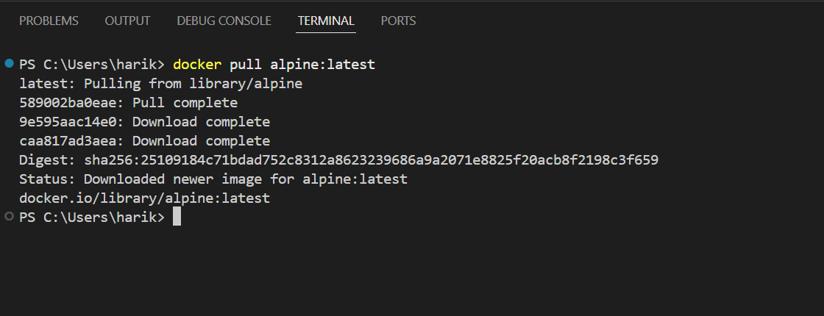
B). Tag that image with your Docker Hub username and login
Cmd= docker tag alpine:latest harikrishna777/ap1:v1.1
Docker login
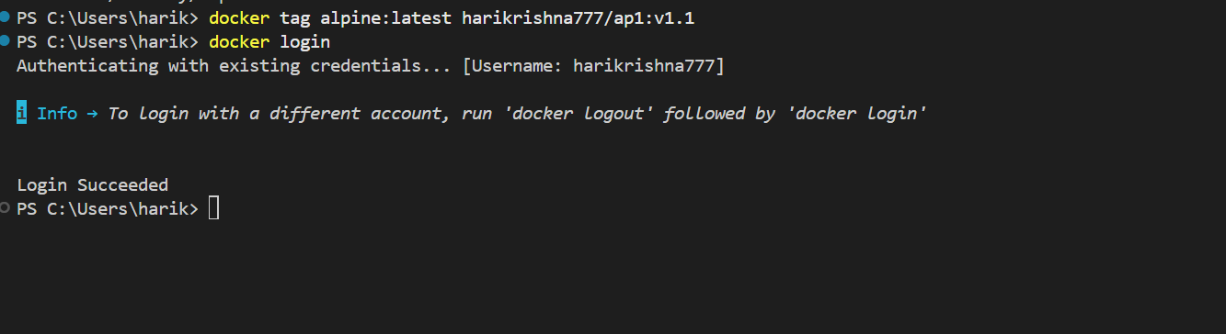
4) Push to Docker Hub
Cmd= docker push harikrishna777/ap1:v1.1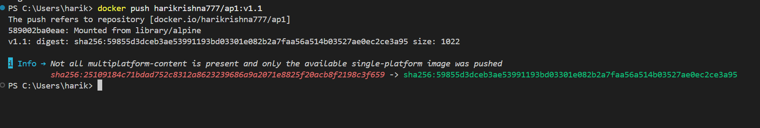B) Update image by making changes inside a container, then push (Run → Change → Commit → Tag → Push)
1) Run container from base/tagged image and interact
Cmd= docker run -it --name a1 harikrishna777/ap1:v1.1 sh
/ # apk update
v3.23.3-129-g1486cfebe03 [https://dl-cdn.alpinelinux.org/alpine/v3.23/main]
v3.23.3-131-g88c6aa978ea [https://dl-cdn.alpinelinux.org/alpine/v3.23/community]
OK: 27572 distinct packages available
/ # apk add php
(1/9) Installing php84-common (8.4.17-r0)
(2/9) Installing argon2-libs (20190702-r5)
(3/9) Installing ncurses-terminfo-base (6.5_p20251123-r0)
(4/9) Installing libncursesw (6.5_p20251123-r0)
(5/9) Installing libedit (20251016.3.1-r0)
(6/9) Installing pcre2 (10.47-r0)
(7/9) Installing xz-libs (5.8.2-r0)
(8/9) Installing libxml2 (2.13.9-r0)
(9/9) Installing php84 (8.4.17-r0)
Executing busybox-1.37.0-r30.trigger
OK: 18.7 MiB in 25 packages
/ # php -v
PHP 8.4.17 (cli) (built: Jan 20 2026 19:04:32) (NTS)
Copyright (c) The PHP Group
Built by Alpine Linux aports
Zend Engine v4.4.17, Copyright (c) Zend Technologies
/ # exit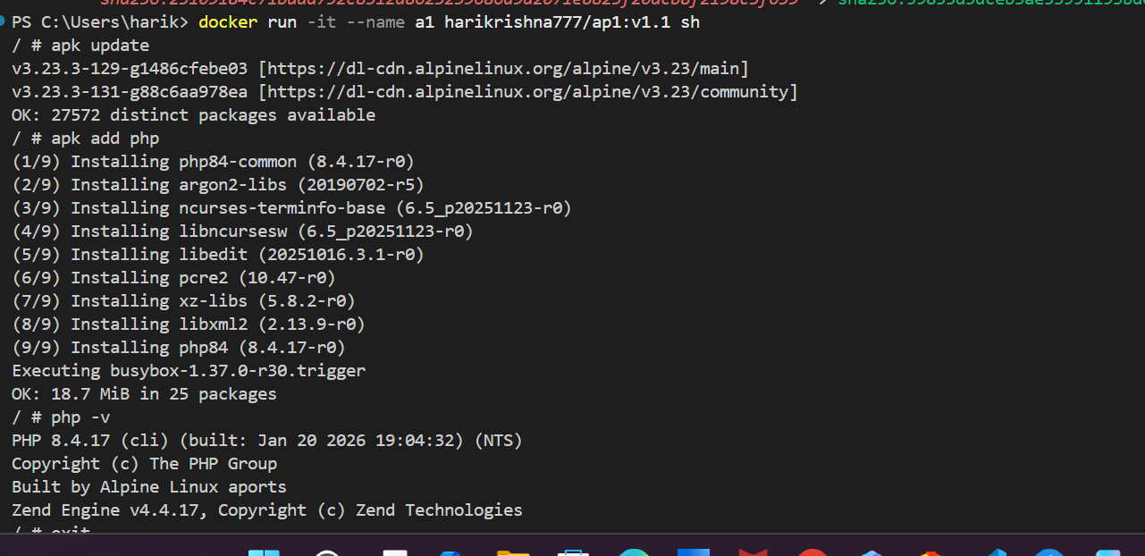
- Commit container changes into a new image
Cmd= docker commit a1 harikrishna777/ap1:v1.2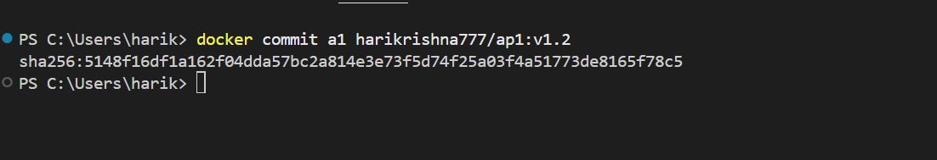
PS C:\Users\harik> docker commit a1 harikrishna777/ap1:v1.2
sha256:5148f16df1a162f04dda57bc2a814e3e73f5d74f25a03f4a51773de8165f78c5
PS C:\Users\harik> docker push harikrishna777/ap1:v1.2
The push refers to repository [docker.io/harikrishna777/ap1]
6d6297d1ade0: Pushed
589002ba0eae: Layer already exists
PS C:\Users\harik> docker run -it --name a2 harikrishna777/ap1:v1.2 sh
>>
/ # php -v
PHP 8.4.17 (cli) (built: Jan 20 2026 19:04:32) (NTS)
Copyright (c) The PHP Group
Built by Alpine Linux aports
Zend Engine v4.4.17, Copyright (c) Zend Technologies
/ # exit
PS C:\Users\harik>
PS C:\Users\harik> docker images harikrishna777/ap1
i Info → U In Use
IMAGE ID DISK USAGE CONTENT SIZE EXTRA
harikrishna777/ap1:v1.1 25109184c71b 13.1MB 3.95MB U
harikrishna777/ap1:v1.2 5148f16df1a1 33.6MB 10.1MB U
PS C:\Users\harik>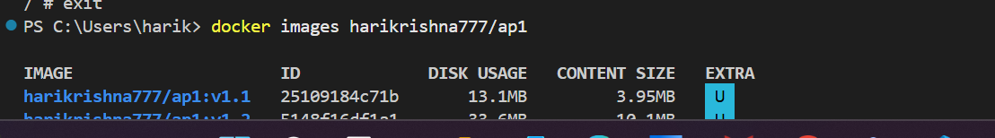
Ex#2(Practice Question):
1.Update the ubuntu
container, install apache and
php, then push updated on
to docker hub.
Cmd= PS C:\Users\harik> docker run -it --name u1 ubuntu:latest bash
root@a66a28628c8a:/# apt update
apt install -y apache2 php
apache2 -v
php -v
docker commit u1 harikrishna777/ubuntu-apache-php:v1.0
docker login
docker push harikrishna777/ubuntu-apache-php:v1.0

exit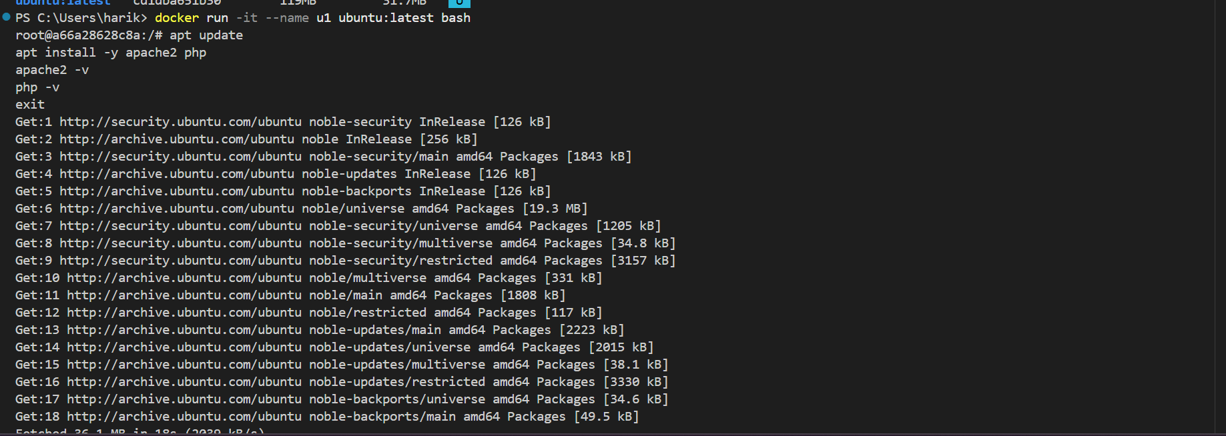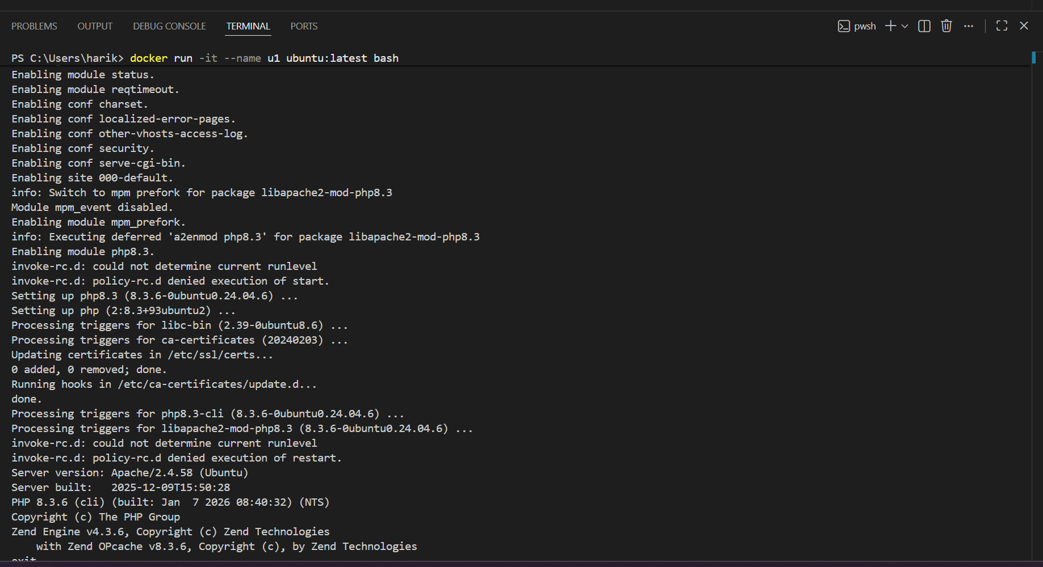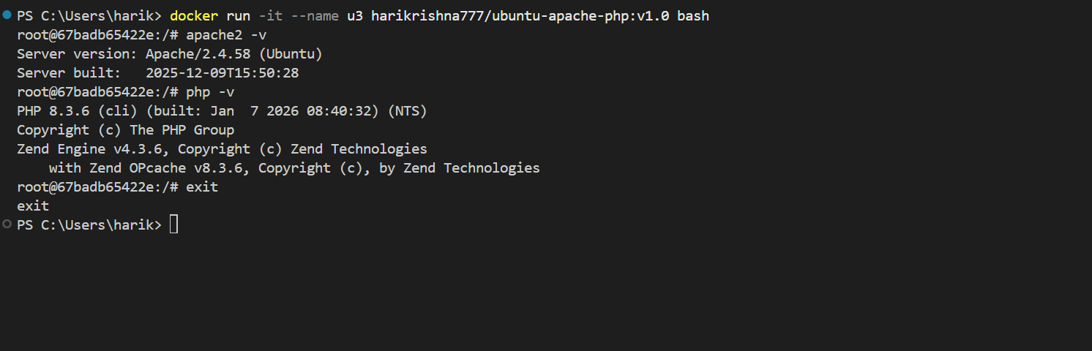
2) Compare size of base image vs updated image (after commit)
Show base Ubuntu size
Cmd= docker images ubuntu
docker images harikrishna777/ubuntu-apache-php
docker images | findstr "ubuntu harikrishna777/ubuntu-apache-php"
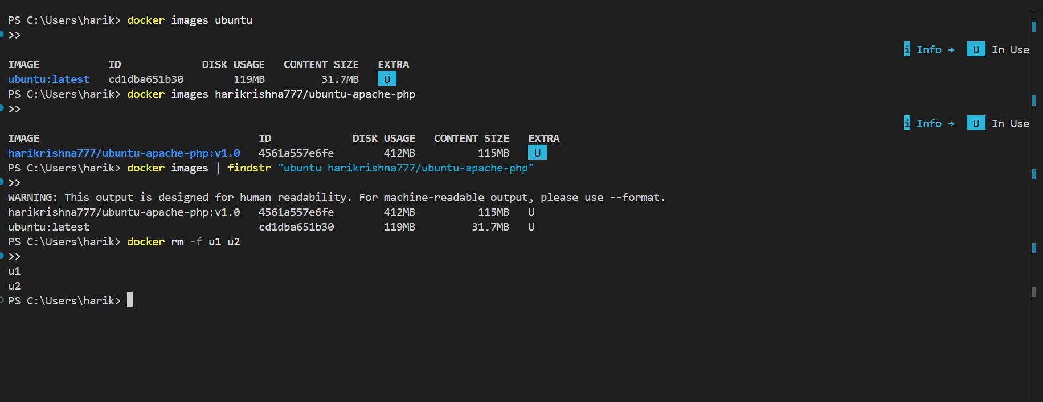

To Create Docker Image by Docker file
PS C:\Users\harik> mkdir ubuntu-docker

Directory: C:\Users\harik

Mode LastWriteTime Length Name
---- ------------- ------ ----
d---- 18-02-2026 00:25 ubuntu-docker

PS C:\Users\harik> cd ubuntu-docker
PS C:\Users\harik\ubuntu-docker> New-Item Dockerfile

Directory: C:\Users\harik\ubuntu-docker

Mode LastWriteTime Length Name
---- ------------- ------ ----
-a--- 18-02-2026 00:26 0 Dockerfile

PS C:\Users\harik\ubuntu-docker> docker build -t harikrishna777/ubuntu-php:v1.0 .
[+] Building 0.4s (1/1) FINISHED docker:desktop-linux
=> [internal] load build definition from Dockerfile 0.2s
=> => transferring dockerfile: 31B 0.0s
ERROR: failed to build: failed to solve: the Dockerfile cannot be empty

View build details: docker-desktop://dashboard/build/desktop-linux/desktop-linux/sf788bpqf56uhso1bqi7w0l0o
PS C:\Users\harik\ubuntu-docker> code Dockerfile
PS C:\Users\harik\ubuntu-docker> code Dockerfile
PS C:\Users\harik\ubuntu-docker> FROM ubuntu:latest
>>
>> LABEL maintainer="harikrishna777"
>>
>> RUN apt update && \
>> apt install -y php && \
>> apt clean
>>
>> CMD ["echo", "Hello Students"]
>>
ParserError:
Line |
1 | FROM ubuntu:latest
| ~~~~
| The 'from' keyword is not supported in this version of the language.
PS C:\Users\harik\ubuntu-docker> rm Dockerfile
PS C:\Users\harik\ubuntu-docker> notepad dockerfile
PS C:\Users\harik\ubuntu-docker> ren dockerfile.txt dockerfile
PS C:\Users\harik\ubuntu-docker> docker build -t harikrishna777/ubuntu-php:v1.0 . 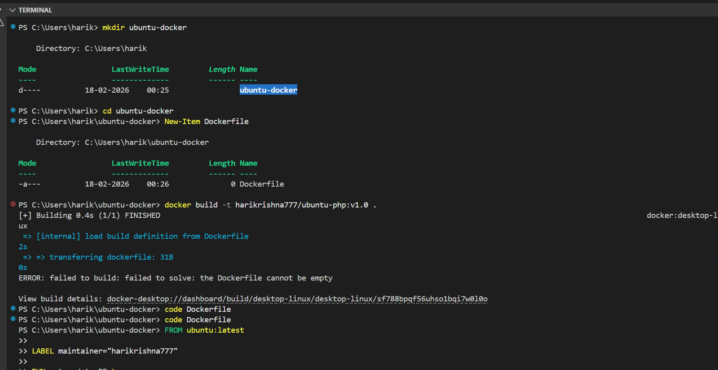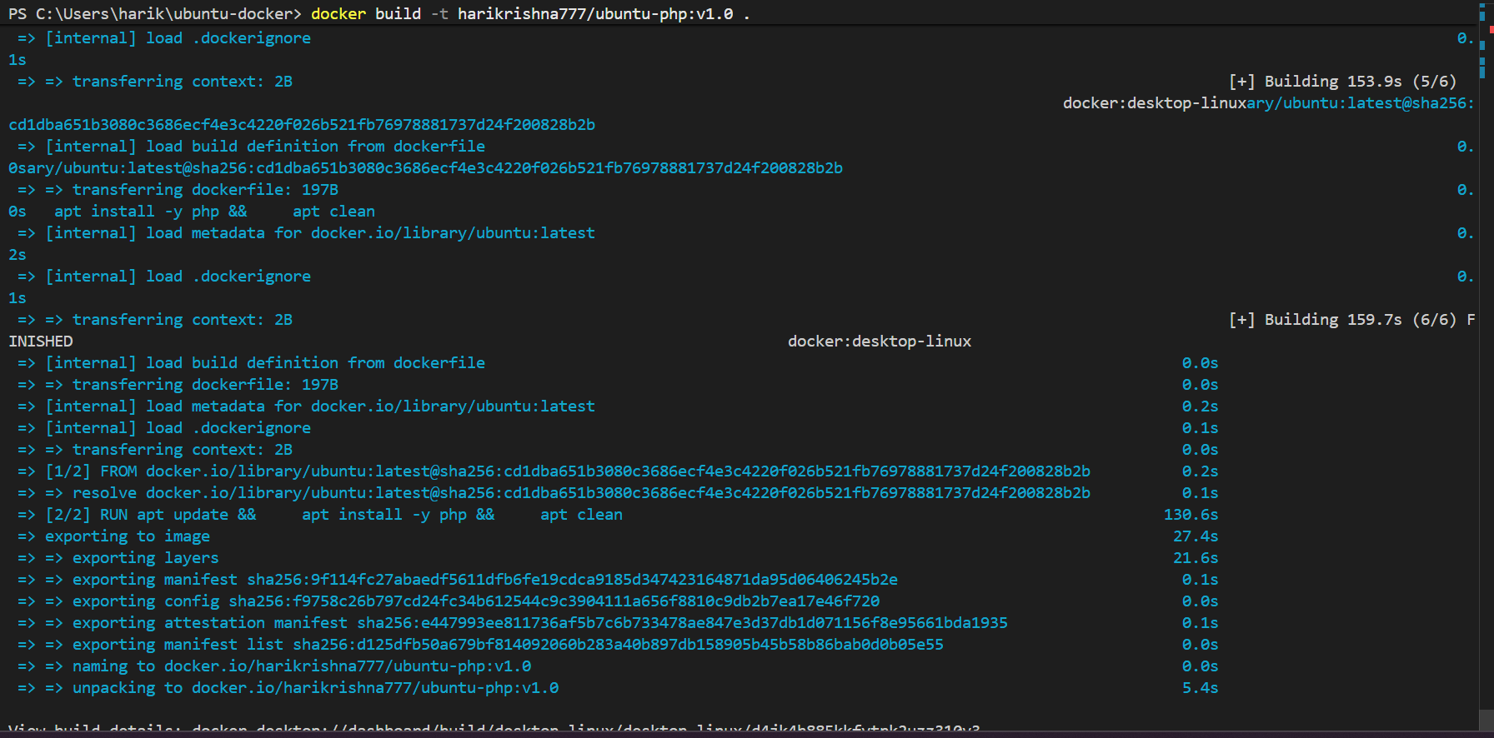

Docker file#3 for Python application
Cmd= mkdir dockerfile_python
cd dockerfile_python
notepad dockerfile
ren dockerfile.txt dockerfile
dir

notepad requirments.txt
notepad app.py
dir
docker build -t harikrishna777/python-flask:v1.0 .
docker run -d --name flask1 -p 5000:5000 harikrishna777/python-flask:v1.0
docker login
docker push harikrishna777/python-flask:v1.0
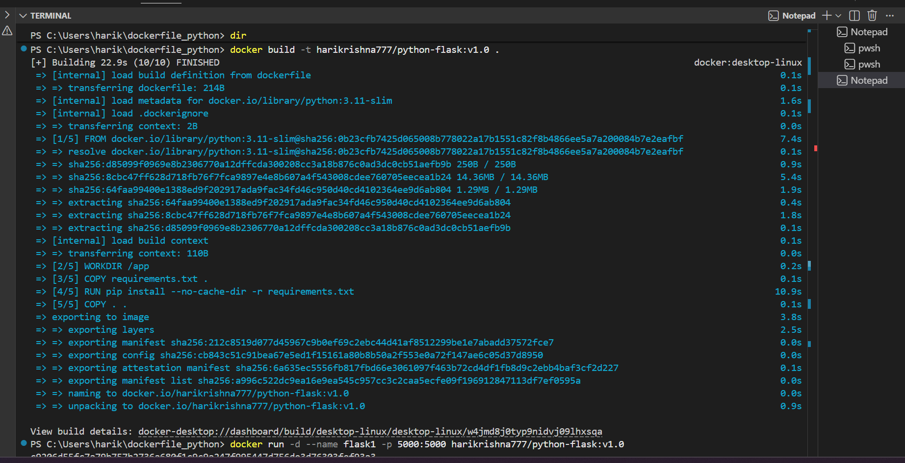

docker push harikrishna777/python-flask:v1.0
The push refers to repository [docker.io/harikrishna777/python-flask]
64faa99400e1: Pushed
d85099f0969e: Pushed
8cbc47ff628d: Pushed
cfea4e4a12ea: Pushed
ed12dcb6ddad: Pushed
6cc5a6ea135c: Pushed
8260c0595952: Pushed
0c8d55a45c0d: Mounted from library/httpd
08e4a24d769d: Pushed
v1.0: digest: sha256:a996c522dc9ea16e9ea545c957cc3c2caa5ecfe09f196912847113df7ef0595a size: 856
PS C:\Users\harik\dockerfile_python>
